Microscopes

Label the compound microscope below and then fill in the table with the microscope part and its function.

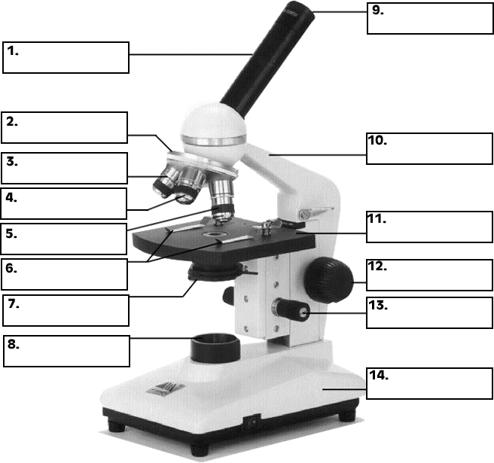

|  |  |  |
| --- | --- | --- |
| Part | Name | Function |
| 1 |  |  |
| 2 |  |  |
| 3 |  |  |
| 4 |  |  |
| 5 |  |  |
| 6 |  |  |
| 7 |  |  |
| 8 |  |  |
| 9 |  |  |
| 10 |  |  |
| 11 |  |  |
| 12 |  |  |
| 13 |  |  |
| 14 |  |  |

1. Define the following terms

a. magnification

b. resolution

c. field of view

d. micrometer

e. nanometer

f. real image

g. virtual image

2. Light is essential for us to view specimens using our microscopes. Describe how the light goes from the bulb to our eyes so we can see our specimen.

3. Adjusting the amount of light is critical. How could adjusting the amount of light change the image of the specimen you are viewing?

4. Some microscopes have an oil immersion objective. What is the role of oil in viewing a specimen?

5. Describe the following types of microscopes in terms of how they work, their magnification power, and what the specimen would look like when viewing it.

a. Light microscope

b. Stereoscope

c. electron microscope

d. Scanning electron microscope

e. Transmission electron microscope

5. How do you determine the total magnification of a microscope?

7. If the ocular lens is 10x and the low power is 23x what is the total magnification? _________

8. Describe the process to focus a specimen from low to high power?

9. Why is it important to only use fine adjustment knob on high power?

10. What should you adjust if the image is too dark? Why?

11. What should you do if you cannot see anything under high power?

12.  When focusing a specimen, you should always start with the ___________________ objective.

13.  When using the high power objective, only the ________   ___________ knob should be used.

14.  The type of microscope used in most science classes is the _________________ microscope

15.  What part of the microscope can adjust the amount of light that hits the slide? ______________________________

16.  You should carry the microscope by the ________ and the __________.

17.  The objectives are attached to what part of the microscope (it can be rotated to click the lenses into place):    _______________    ________________

18.  You should always store you microscope with the  ________________ objective in place.

19.  A microscope has an ocular objective of 10x and a high power objective of 50x.  What is this microscope's total magnification?  ____________

20. How do you determine the field of view?

21. How many microns/micrometers are in 2 mm? 3.2 mm?

22. If the high power field of view is 375 μm, how many mm is that? ____________

If I estimated that 3.5 specimens could fit across the field of view, how big is my specimen, in mm and μm?

23. If each specimen is 30 μm, and 10 can fit across, how big is the field of view?

24. If each specimen is 120 μm and the field of view is 630 mm, how many can fit across?

25. What do you clean the microscope with?

26. What do you do with the cord of the microscope before putting it away?

27. What position will you put the stage in when you are done with the microscope?